Q Solutions, LLC
Home
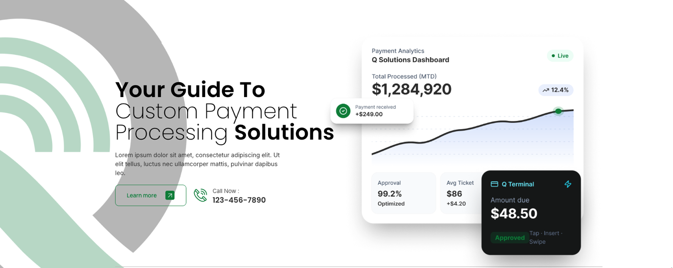
Subheading: Smart technology, transparent pricing, and dedicated support—everything your business needs to accept payments with confidence.
Call Now: (877) 609-6377
Learn More: Links to About Us
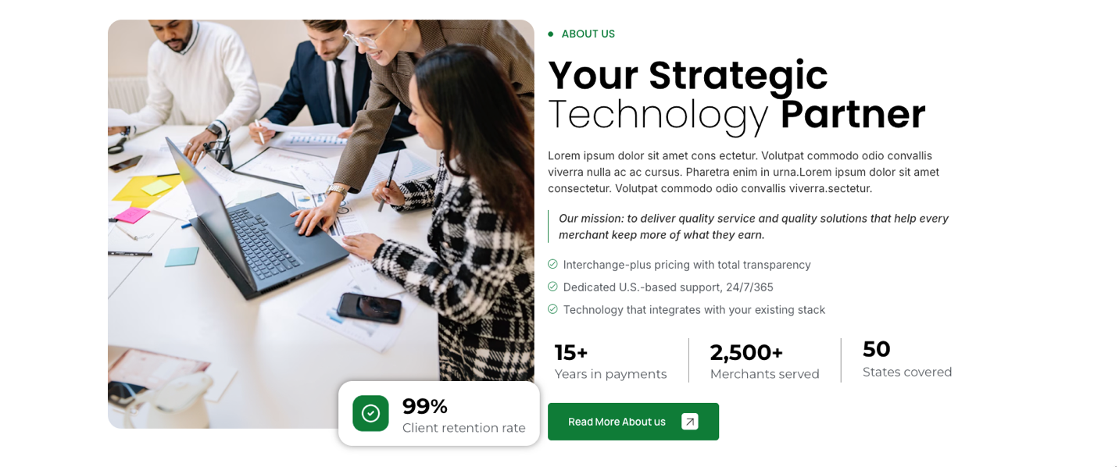
Sub Heading: More than a provider—we're a trusted technology partner delivering intelligent payment solutions, modern business systems, and personalized support to help your business stay ahead.
Second Check Mark: “Remove 24/7/365”
Merchants Served : “5000+”
States Covered change to – “Processed Annually: $28B+”
Retention Rate – Change to “Transactions processed: 20M+”
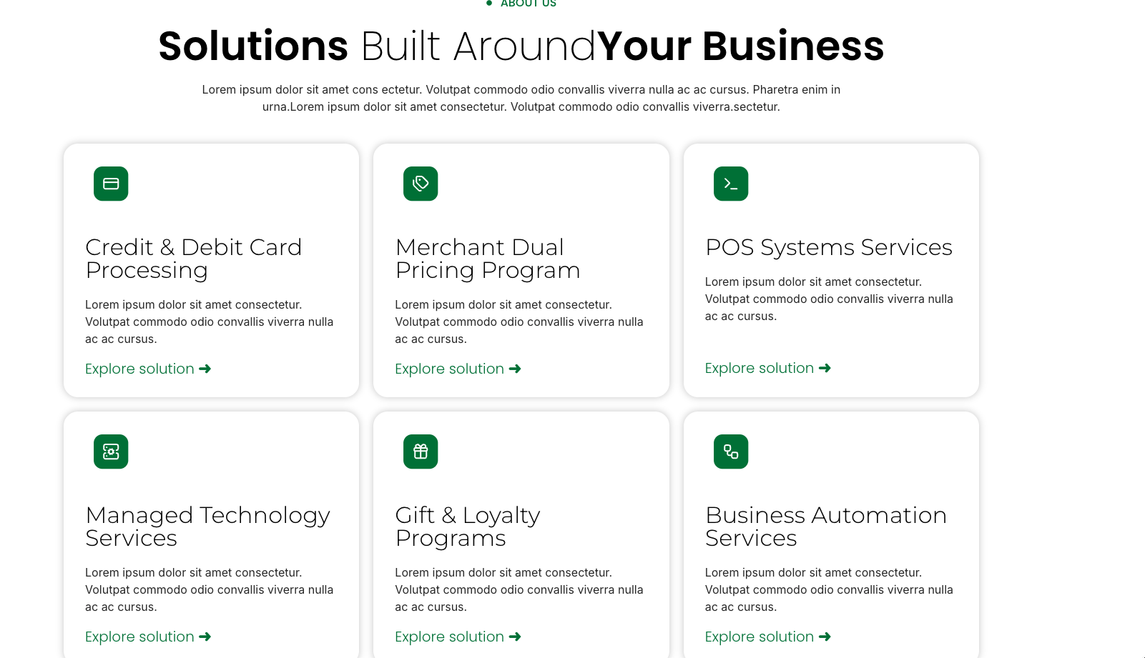
About us label change to solutions or services

Solutions Built About Your Business Subheading: Every business operates differently. We take the time to understand your unique needs and deliver customized payment, POS, and technology solutions that drive efficiency, security, and sustainable growth.

Credit & Debit Subheading : Reliable payment processing built around your business. We provide transparent pricing, modern payment technologies, and dedicated support.

Merchant Dual Pricing Subheading: Save up to 90% on credit card processing fees. We’ll optimize your payments and save you money.
Learn about the Pros & Cons of Dual Pricing – Hyperlink to blog post (https://gowithq.com/dual-pricing-explained-pros-cons-considerations-more/)

POS System Services subheading- Powerful POS Solutions tailored to your industry. Streamline operations and improve efficiency across every location.

Managed Technology Services Subheading: Technology solutions that help your business stay connected, productive, and secure.

Gift & Loyalty Program Subheading: Essential Gift gives you the tools to get your gift program off the ground and contend with the big competitors.

Change Business Automation to Security and Compliance

Security and Compliance Subheading : Protect your business with secure payment environments and compliance-focused solutions.
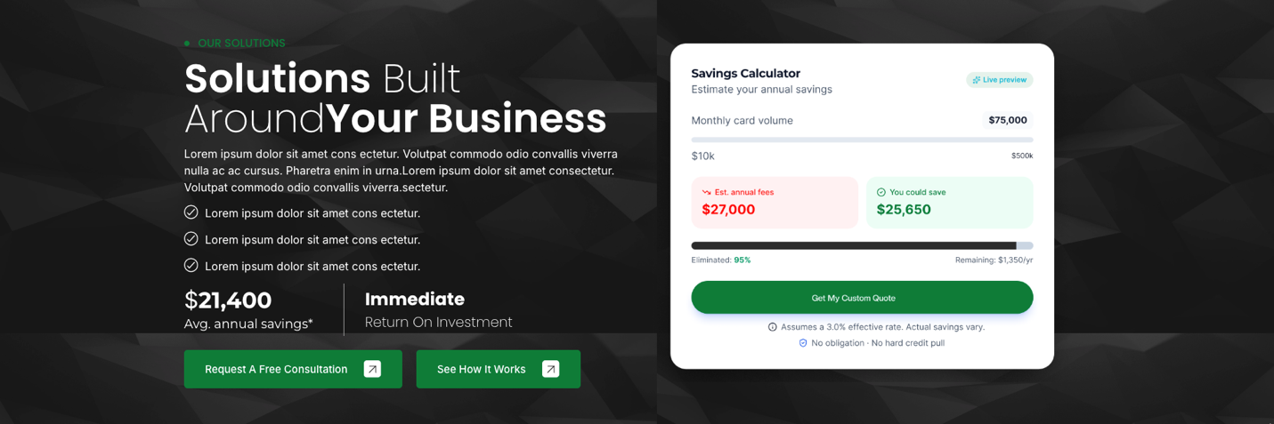

Savings Calculator : JotForm - <script type="text/javascript" src="https://form.jotform.com/jsform/250856467076063"></script>

Change Solutions Built Around Your Business to: Reduce Processing Costs with Our Merchant Dual Pricing Program
Subheading: Offer customers more payment choices while reducing payment processing costs with a compliant, transparent dual pricing solution that is easy to implement and simple to manage.

- Reduce or offset credit card processing expenses while maintaining transparent pricing
- Fully compliant dual pricing solutions with proper signage, receipts, and implementation guidance
- Seamless integration with compatible POS systems and payment terminals, backed by ongoing local support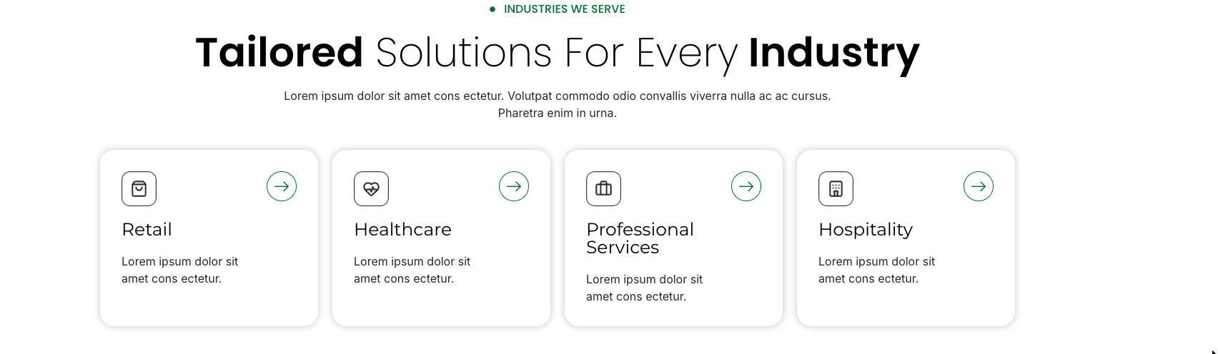
Subheading: With our extensive experience in a variety of industries, we have the expertise to provide tailored payment solutions for our partners’ unique needs in various sectors including retail, restaurants, healthcare, and petroleum services. Now Offering High Risk Solutions

Retail: Modern payment and POS solutions that help retailers serve customers faster and operate more efficiently.

Healthcare: Secure payment solutions designed to simplify patient payments and support healthcare practices.

Professional Services (Change to Petroleum): Reliable payment and fuel technology solutions built for convenience stores, truck stops, and fuel retailers.
Hospitality: Flexible payment and POS solutions that help restaurants, bars, hotels, and entertainment venues deliver exceptional guest experiences.


Subheading: Compare your current rates, uncover hidden fees, and explore smarter payment solutions.

Change Find Specialist near you to “Request A Savings Analysis today” – link to Statement Analysis – Jot Form - <script type="text/javascript" src="https://form.jotform.com/jsform/251204454691050"></script>

Businesses Supported: 5000+
Transactions processed: 20m+
Years in business: 15+
Processed Annually: $28B+

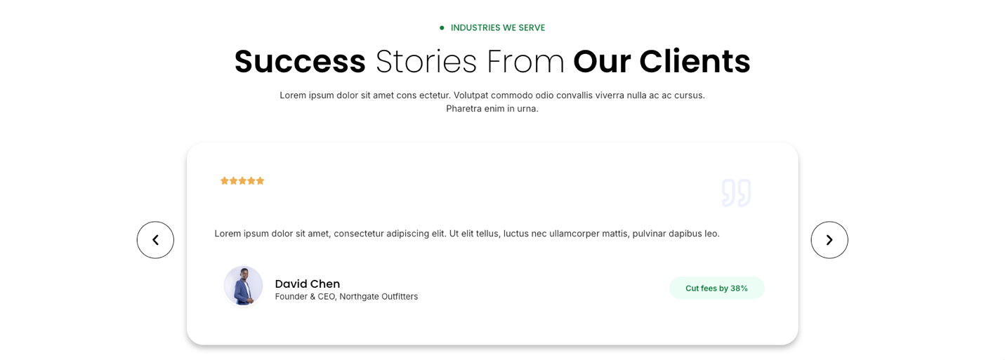

Subheading: From local businesses to multi-location operations, our clients count on Q Solutions for innovative technology and trusted support.

Testimonials:
“As one of Q Solutions, LLC’s first customers, I was impressed with the competitive rates I received at my pharmacy. I’ve stuck with Q Solutions, LLC over the years because they offer wonderful customer service and the knowledge to back it up.”

Mike Burns

Auburn Pharmacies

“I don’t often say anything about any company publicly, but Keith and Taryn are the absolute best in the industry. If anybody needs any credit card processing or even billing solutions with integrated processing, they are the best to take care of you, down to earth, and most importantly, honest. I cannot say enough good things about them. They have taken care of us for over 13 years, and some of our clients for 20+. You won’t find anyone else who is willing to sit down and explain everything without the ridiculous sales pitch that they can always save you money, just don’t read the fine print. ” I don’t know how many times I’ve called Keith and gotten a prompt and 100% honest response in layman’s terms and honesty. They make sure I’m in compliance with the lowest fees possible. They’ve saved us more money than I can describe over the years, and with the bonus of local ownership, you can call them directly.”

Daniel McNary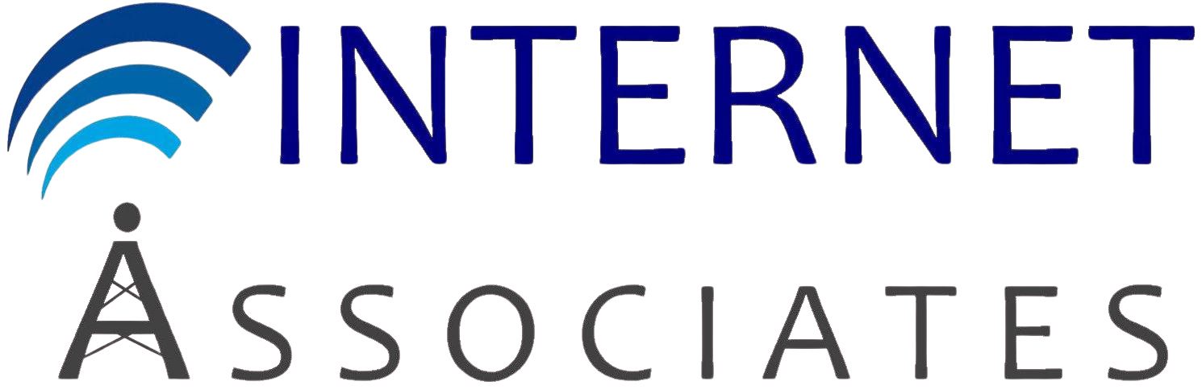
Internet Associates

“Q Solutions, LLC has made it so easy for our company to provide reliable and safe transactions for our students. Anytime I need information or a quick fix Taryn is right there in a timely manner to help out. Setup was easy, and I know our customers’ information is safe.”

Sarah McAfee
Options For Animals

“We are extremely pleased with our decision to partner with Q Solutions, LLC. Their team has provided invaluable support in helping us navigate the path of accepting credit card payments as part of a broader strategy.”

Clark Balcom
PBA Health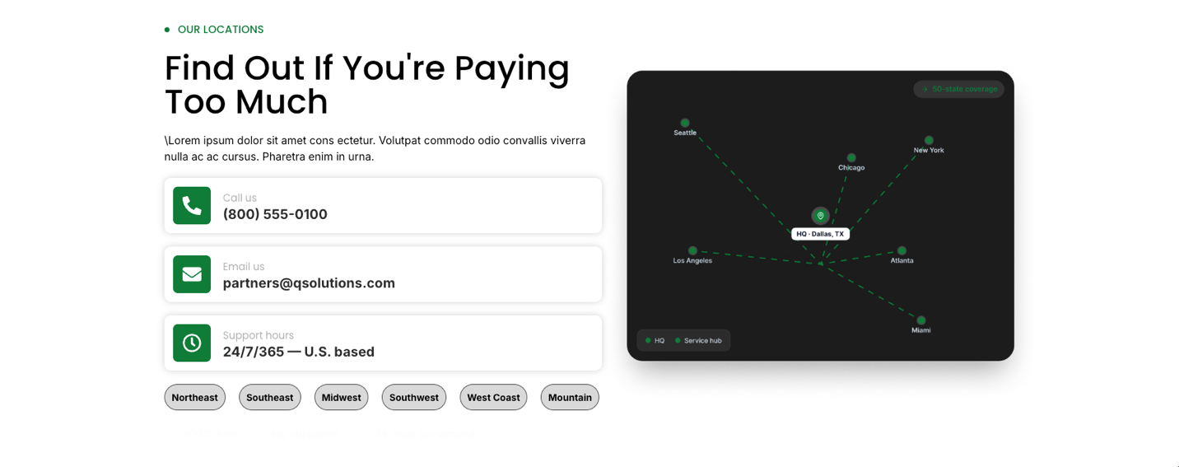

Subheading: Local expertise with nationwide support, delivering customized solutions wherever your business operates.

Call Us: (877) 609-6377
Email Us:
info@gowithq.com
Support Hours: Mon – Fri: 8:30 AM – 5:00 PM CST

Office Locations:
Wellsville, KS
Cedar, Oak Grove, MN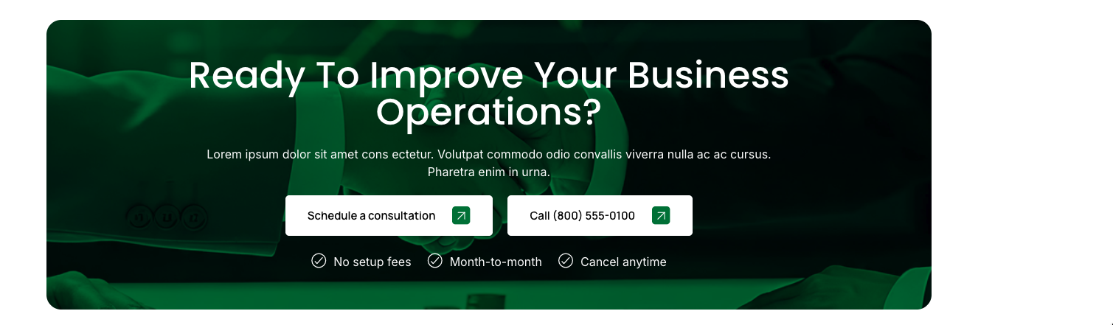
Subheading: Partner with Q Solutions to streamline operations, reduce costs, and equip your business with technology built for growth.

Call (877) 609-6377

About Us
Sub Heading: More than a provider—we're a trusted technology partner delivering intelligent payment solutions, modern business systems, and personalized support to help your business stay ahead.
Second Check Mark: “Remove 24/7/365”
Merchants Served : “5000+”
States Covered change to – “Processed Annually: $28B+”
Retention Rate – Change to “Transactions processed: 20M+”

Our Vision: We envision a future where every business—regardless of size—has access to enterprise-quality payment processing, point-of-sale systems, and business technology backed by transparent guidance, exceptional service, and trusted partnerships. By combining innovation with a customer-first approach, we strive to help businesses operate smarter, grow confidently, and thrive in an ever-changing marketplace.

Our mission: Our mission is to build lasting partnerships by providing reliable payment processing, modern business technology, and personalized support. Through integrity, innovation, and a commitment to excellence, we help businesses reduce complexity, improve efficiency, and achieve long-term success.

Businesses Supported: 5000+
Transactions processed: 20m+
Years in business: 15+
Processed Annually: $28B+
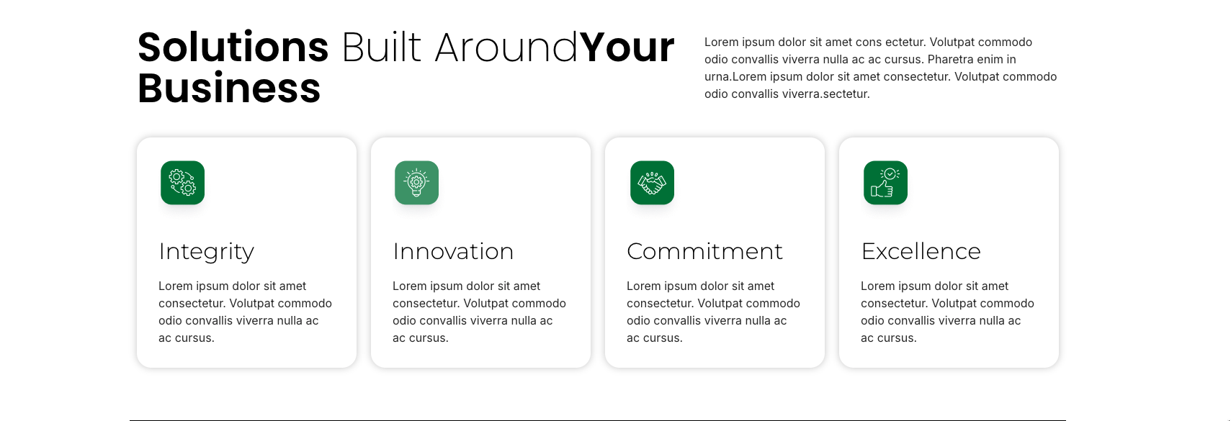

Subheading: Every business is unique. We deliver customized payment and technology solutions designed to improve efficiency, enhance security, and support your long-term success.

Integrity
We build lasting relationships through honesty, transparency, and doing what's right for our clients every step of the way.

Innovation
We embrace evolving technology to deliver smarter, more efficient solutions that help businesses stay ahead.

Commitment
We are dedicated to exceptional service, responsive support, and the long-term success of every client we serve.

Excellence
We strive for the highest standards in every solution, every interaction, and every partnership, delivering quality you can trust.
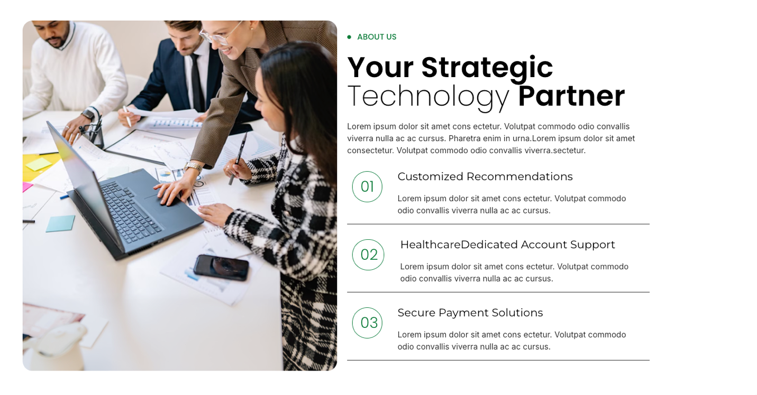

About Us

Your Strategic Technology Partner
Helping businesses simplify operations with secure payment processing, modern point-of-sale systems, and customized technology solutions backed by exceptional service and transparent pricing.

01

Customized Solutions
Every business operates differently. We take the time to understand your goals and recommend payment and technology solutions tailored to your operations, budget, and future growth.

02

Dedicated Account Support
From implementation to ongoing service, you'll work with a knowledgeable team that provides responsive support, proactive guidance, and personalized assistance every step of the way.

03

Secure & Reliable Technology
Protect your business with trusted payment processing, modern POS systems, and secure technology solutions designed to keep your operations running efficiently and your data protected.


Subheader: Meet the professionals who are passionate about helping businesses streamline operations, reduce costs, and grow through smarter technology solutions.

Keith Dougan
Founder & Chief Executive Officer

Brandy Dougan
President


Taryn Newcome
Office Administrator & Customer Success Specialist


Kellie Grayden
Partner

Anthony Grayden
Partner

Andrew Dougan
Director of Business Development

Subheading: Partner with Q Solutions to streamline operations, reduce costs, and equip your business with technology built for growth.

Call (877) 609-6377

Solutions
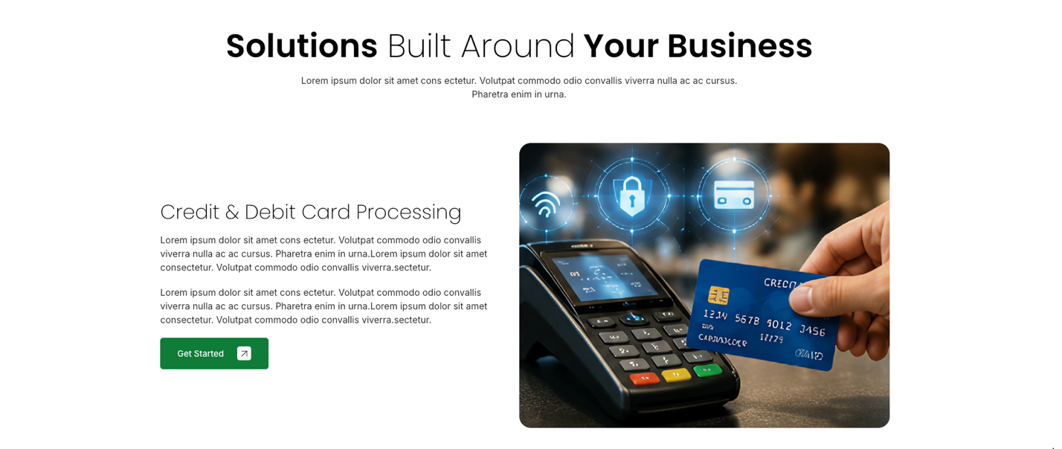
Subheading: Every business is unique. We deliver customized payment and technology solutions designed to improve efficiency, enhance security, and support your long-term success.

Credit & Debit Card Processing Subheading: Accept payments with confidence through secure, reliable processing solutions that provide transparent pricing, fast funding, and exceptional support. Whether you operate a single location or a growing multi-site business, we'll build a payment solution tailored to your needs.

Key Benefits
✓ Transparent, competitive pricing with no hidden surprises
✓ Fast, secure payment processing with EMV, contactless, and mobile payment support
✓ Dedicated local support backed by industry expertise
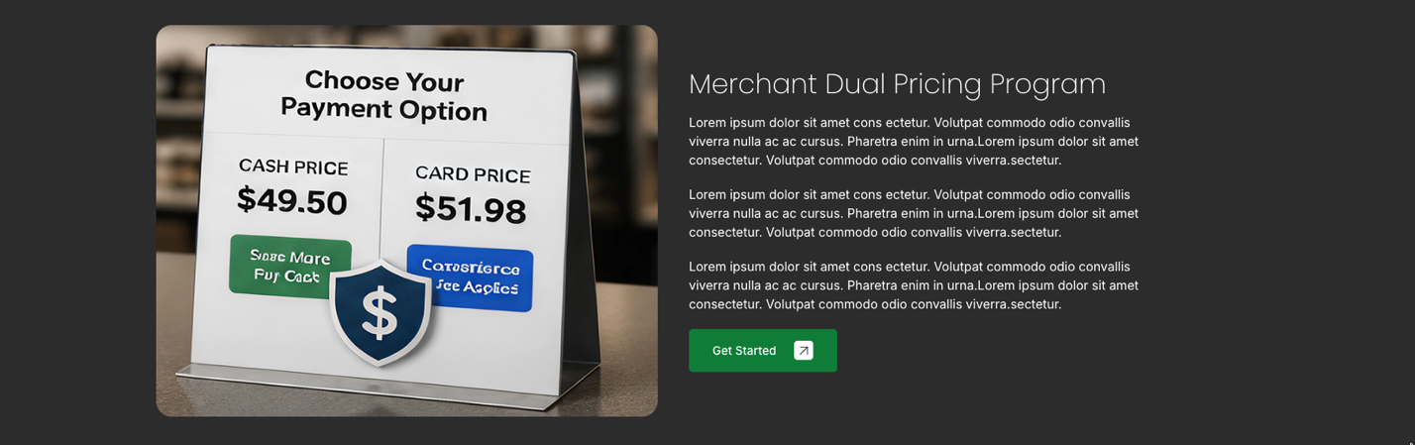

Merchant Dual Pricing Program
Reduce payment processing costs with a compliant dual pricing solution that gives customers clear payment options while helping protect your bottom line. Our team handles the implementation, training, and ongoing support so you can transition with confidence.

Why Choose Our Dual Pricing Program?
✓ Reduce or offset credit card processing expenses while maintaining transparent customer pricing.
✓ Compliant implementation with proper signage, receipt formatting, and customer communication.
✓ Seamless integration with compatible POS systems and payment terminals, backed by local, responsive support.
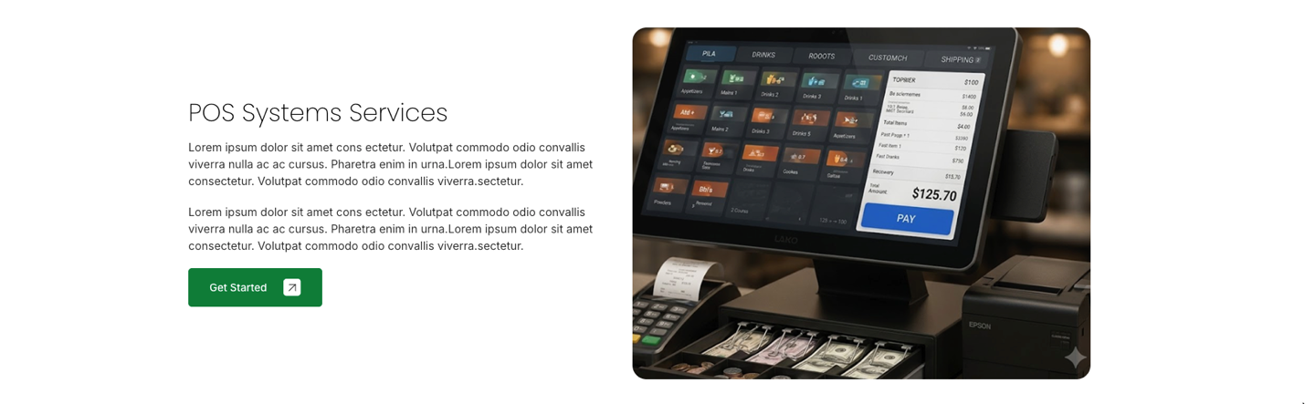

POS System Services
Empower your business with modern point-of-sale solutions designed to streamline operations, improve customer experiences, and keep your business running efficiently. Whether you're in retail, hospitality, healthcare, or petroleum, we'll help you find the right POS system for your unique needs.

Why Choose Our POS Solutions?
✓ Industry-specific POS systems tailored for retail, restaurants, convenience stores, healthcare, and service businesses.
✓ Powerful features including inventory management, employee controls, reporting, customer management, and integrated payment processing.
✓ Professional installation, staff training, and ongoing local support to ensure your business operates with confidence.
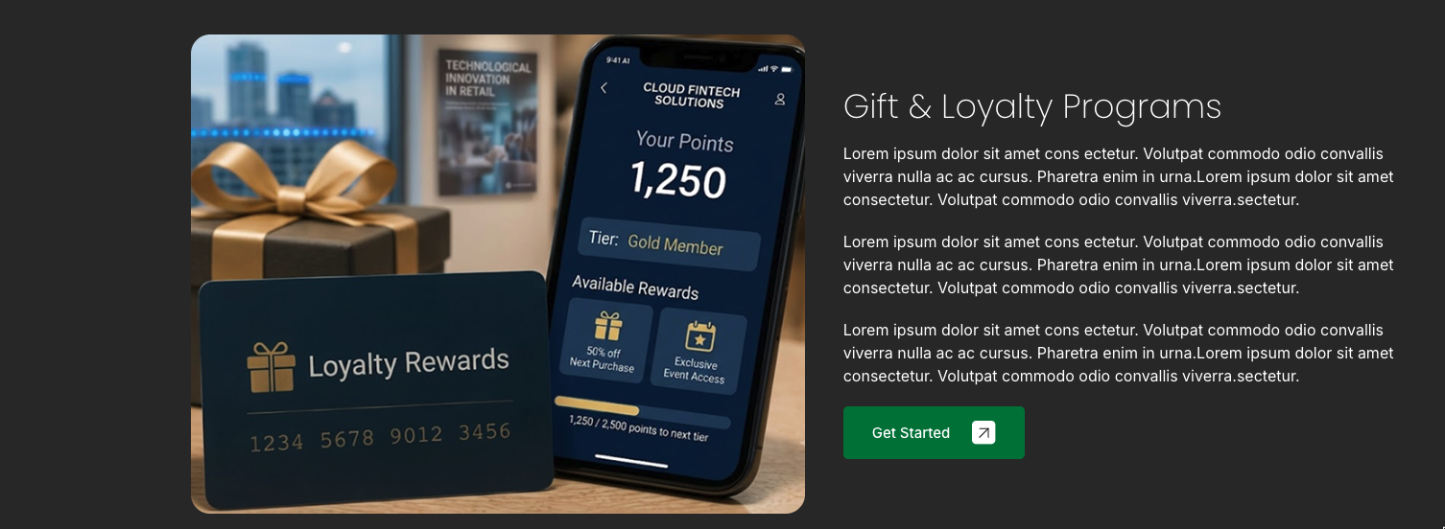

Gift & Loyalty Programs
Build stronger customer relationships and encourage repeat business with customizable gift card and loyalty programs that reward your customers and help grow your revenue.

Why Choose Our Gift & Loyalty Solutions?
✓ Custom-branded gift cards and digital loyalty programs tailored to your business.
✓ Reward repeat customers with points, promotions, discounts, and exclusive offers that drive customer retention.
✓ Seamlessly integrated with your POS system for easy management, real-time tracking, and valuable customer insights.
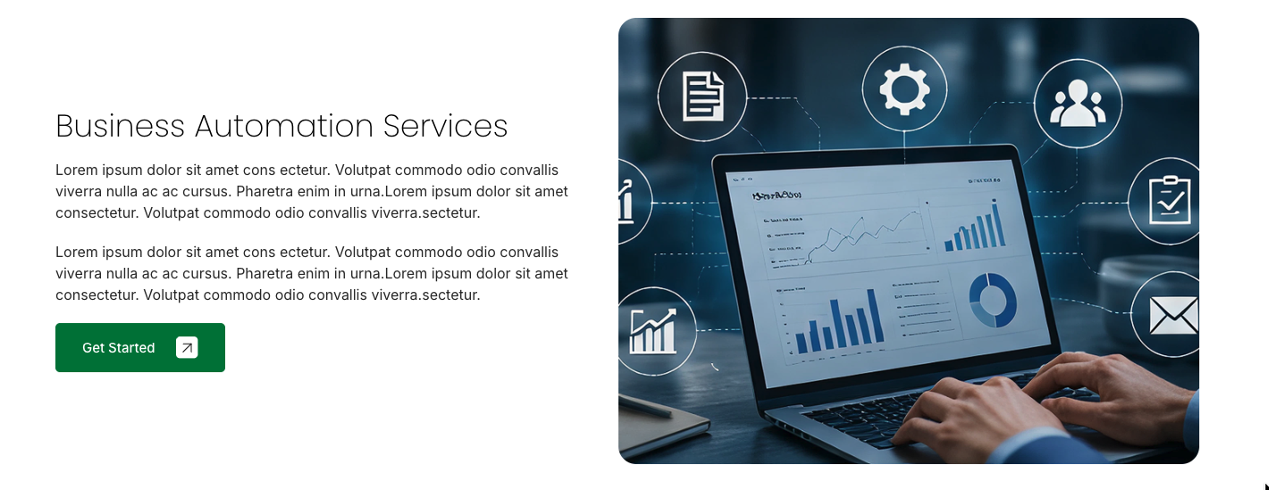
Change to Security and Compliance

Security & Compliance
Protect your business with secure payment technology and compliance solutions designed to safeguard sensitive data, reduce risk, and help you maintain customer trust.

Why Choose Our Security & Compliance Solutions?
✓ PCI compliance guidance and secure payment technologies to help protect cardholder data.
✓ Advanced fraud prevention, EMV, contactless, and encrypted payment solutions.
✓ Ongoing security updates, compliance support, and expert guidance to keep your business protected.
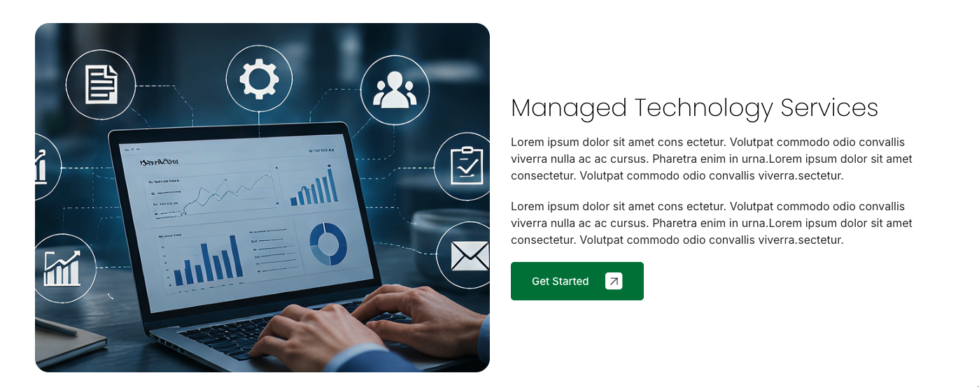

Managed Technology Services
Keep your business connected, secure, and running at peak performance with proactive technology solutions designed to minimize downtime, improve productivity, and support your long-term growth.

Why Choose Our Managed Technology Services?
✓ Proactive monitoring, maintenance, and support to keep your technology operating smoothly.
✓ Reliable network, cloud, and infrastructure solutions tailored to your business needs.
✓ Responsive expert support that helps prevent issues before they impact your business.
Industries

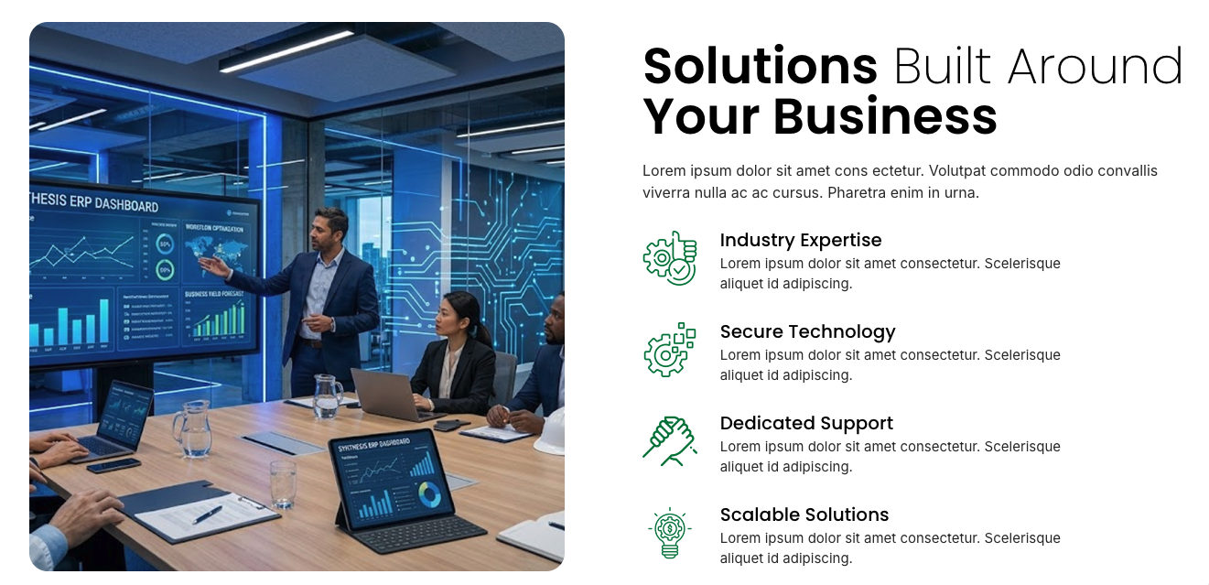
From customized payment processing to advanced business technology, we build solutions around your goals—helping you operate smarter, reduce complexity, and grow with confidence.

Industry Expertise
Our experienced team understands the unique challenges of your industry and delivers technology solutions tailored to your business.

Secure Technology
Protect your business with reliable payment systems, advanced security, and technology designed to safeguard your operations and customer data.

Dedicated Support
Receive responsive, personalized support from a team committed to helping your business succeed before, during, and after implementation.

Scalable Solutions
Flexible payment and technology solutions that grow with your business, from a single location to multi-site operations.
Subheading: With our extensive experience in a variety of industries, we have the expertise to provide tailored payment solutions for our partners’ unique needs in various sectors including retail, restaurants, healthcare, and petroleum services. Now Offering High Risk Solutions

Retail: Modern payment and POS solutions that help retailers serve customers faster and operate more efficiently.

Healthcare: Secure payment solutions designed to simplify patient payments and support healthcare practices.

Professional Services (Change to Petroleum): Reliable payment and fuel technology solutions built for convenience stores, truck stops, and fuel retailers.
Hospitality: Flexible payment and POS solutions that help restaurants, bars, hotels, and entertainment venues deliver exceptional guest experiences.
Resources

FileBird Pro
Blog information
Contact Us

Subheading: Local expertise with nationwide support, delivering customized solutions wherever your business operates.

Call Us: (877) 609-6377
Email Us:
info@gowithq.com
Support Hours: Mon – Fri: 8:30 AM – 5:00 PM CST

Office Locations:
Wellsville, KS
Cedar, Oak Grove, MN

Forminator Pro Contact Form - [forminator_form id="637"]

Merchant Logins

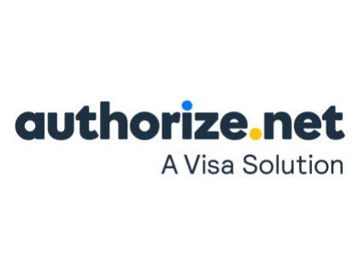
https://login.authorize.net/ 
https://merchant.billergenie.com/ 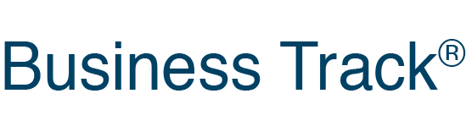https://www.businesstrack.com/ 
https://www.pciapply.com/CLRO

https://celerocommerce.transactiongateway.com/merchants/login 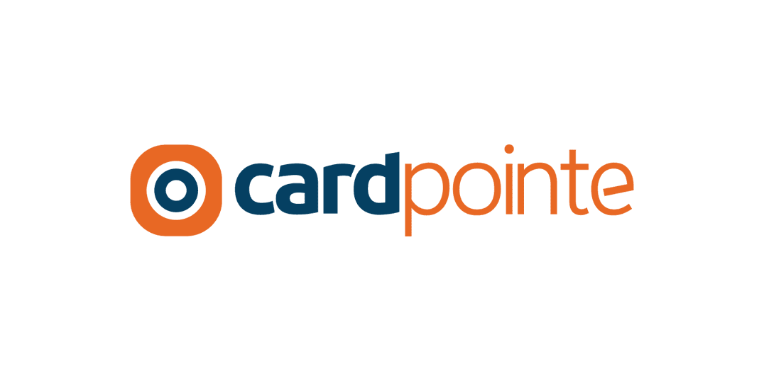
https://cardpointe.com/ 
https://app.gotnpgateway.com/auth 
https://www.celerocompass.com/v2/login 
https://cloversecurity.com/safemaker/login/portal 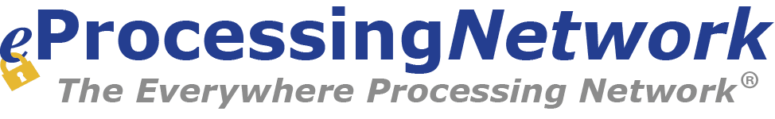
https://www.eprocessingnetwork.com/msclogin.html 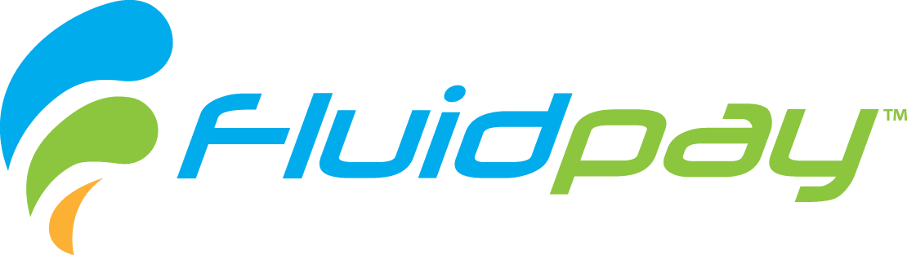
https://app.fluidpay.com/auth
https://insights.modisoft.com/account/logon

https://paytrace.com/login.pay
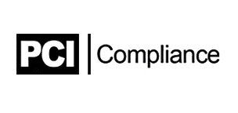
https://www.pciapply.com/pcicompliance 
https://swipesimple.com/sign_in

https://translink.transfirst.com/login.aspx 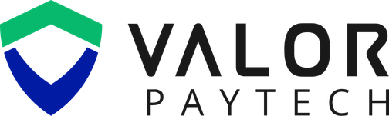
https://online.valorpaytech.com/login
Merchant Portal
https://www.vtmerchantportal.com/
Card Manager Portal
https://www.storecard.com/vt

Partner Login
https://www.clover.com/login
https://partner.authorize.net/widget/widget/RINT/SPAhttps://partners.billergenie.com/
https://www.pciapply.com/CLRO
https://cardpointe.com/
https://app.gotnpgateway.com/auth
https://www.celerocompass.com/v2/login
https://cloversecurity.com/safemaker/login/portal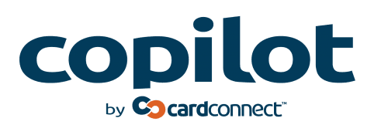
https://copilot.cardconnect.com/copilot/
https://www.eprocessingnetwork.com/rsclogin.html
https://app.fluidpay.com/auth
https://insights.modisoft.com/account/logon
https://paytrace.com/login.pay
https://www.pciapply.com/pcicompliance
https://swipesimple.com/sign_in
https://translink.transfirst.com/login.aspx
https://online.valorpaytech.com/login

